

Travlr Getaways

CS 465 Project Software Design Document
Version 3.1

Table of Contents

CS 465 Project Software Design Document 1
Table of Contents 2
Document Revision History 2
Executive Summary 3
Design Constraints 3
System Architecture View 4
Component Diagram 4
Sequence Diagram 6
Class Diagram 7
API Endpoints 8
The User Interface 10

Document Revision History

Version | Date | Author | Comments
1.0 | 09/20/26 | Marwan Alrifaie | Completed Milestone One executive summary, design constraints, and component architecture description
2.0 | 10/04/26 | Marwan Alrifaie | Completed Milestone Two sequence and class explanations and API endpoint table; included both completed diagrams.
3.0 | 10/16/26 | Marwan Alrifaie | Updated the final architecture, security, API endpoints, SPA screenshots, and test results.
3.1 | 10/18/26 | Marwan Alrifaie | Added customer accounts, search, reservations, staff management, and browser evidence.

Executive Summary

Travlr Getaways has three main parts: the pages users see, the server, and the database. Keeping them separate makes the application easier to update. The application uses the MEAN stack. MongoDB stores the data, Express handles routes and API requests, Angular runs the administrator single-page application (SPA), and Node.js runs the server.

The customer website uses Express controllers and Handlebars templates to show trips from MongoDB through the REST API. Customers can create an account, search by location or price, reserve an upcoming trip, and view their itinerary later. Staff use the Angular SPA to manage trips, customer access, and reservations. Both sites share one database, so saved changes appear when the customer page reloads.

Design Constraints

The application follows these design constraints:

- Node.js and Express: The server uses Node.js and Express to handle routes, controllers, and the REST API.
- Handlebars: The customer site uses the Travlr layout and templates to display current trip information.
- Shared data: Both sites use MongoDB. The JSON file is only used to add sample trips to the database.
- Angular SPA: The trip listing and the Add and Edit screens use reusable components and reactive forms.
- MongoDB and Mongoose: Schemas check trip, staff, customer, and reservation data. Each trip code and customer email must be unique.
- Security: Staff and customer passwords are salted and hashed. Their tokens are intended for different users, so a customer token cannot access staff endpoints. Customer forms also check a signed CSRF token.

These choices also affect how the application is used and tested:
- MongoDB and Express must be running for either site to load saved trips.
- During local development, Express uses port 3000 and Angular uses port 4200. CORS allows Angular to send requests to Express.
- Handlebars builds pages on the server. Angular updates screens in the browser and requests JSON when it needs data.
- The project keeps Angular 17 to match the course version. Its dependency check still reports security issues, so Angular needs an upgrade before the application is released publicly.
- Login tokens expire after one hour. The application needs clear messages for invalid entries, expired sessions, and failed requests. These errors should not remove saved database records.

System Architecture View

Component Diagram

The supplied component diagram groups the application into Client, Server, and Database areas. These are the main parts and how they map to the code:
- Web Browser: Displays the Express customer site or the Angular administrator SPA.
- Traveler Portfolio: Represents the trip information shown to the visitor.
- Graphic Library: Supplies the images and styles stored in public and the Angular assets folder.
- Client Session: Angular keeps its staff token in sessionStorage for the current tab. Express keeps the customer token in an HttpOnly cookie.
- Node.js and Express Server: Routes requests to controllers, renders Handlebars pages, and provides the JSON API.
- Authentication Server: Passport checks the staff password. The authentication controller then returns a signed JSON Web Token.
- Server Session: Protected requests verify the token and the current staff or customer account. Customer forms also check their origin and CSRF token.
- Traveler Database: Mongoose models store shared trip details, customer accounts, staff accounts, and saved reservations.
- Mongoose ODM: Validates application data and sends database operations to MongoDB.
- MongoDB: Stores trips, staff, customers, and reservations in separate collections.

The browser sends requests to Express, and controllers use Mongoose to reach MongoDB. Trip browsing and search are public. Staff tokens protect administration, while customer tokens protect each customer’s own reservations. Authentication runs inside the same Express application; the diagram shows its logical role, not a separate deployed server.
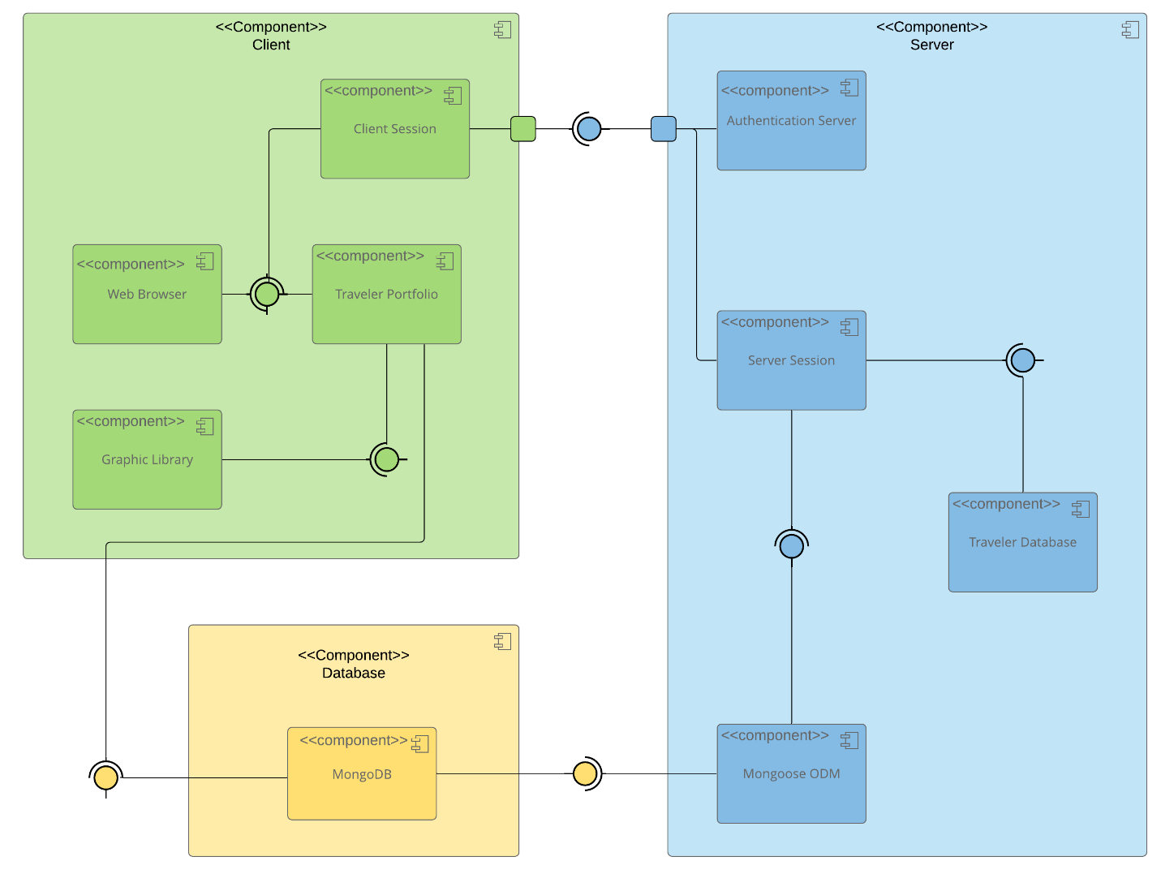

Sequence Diagram
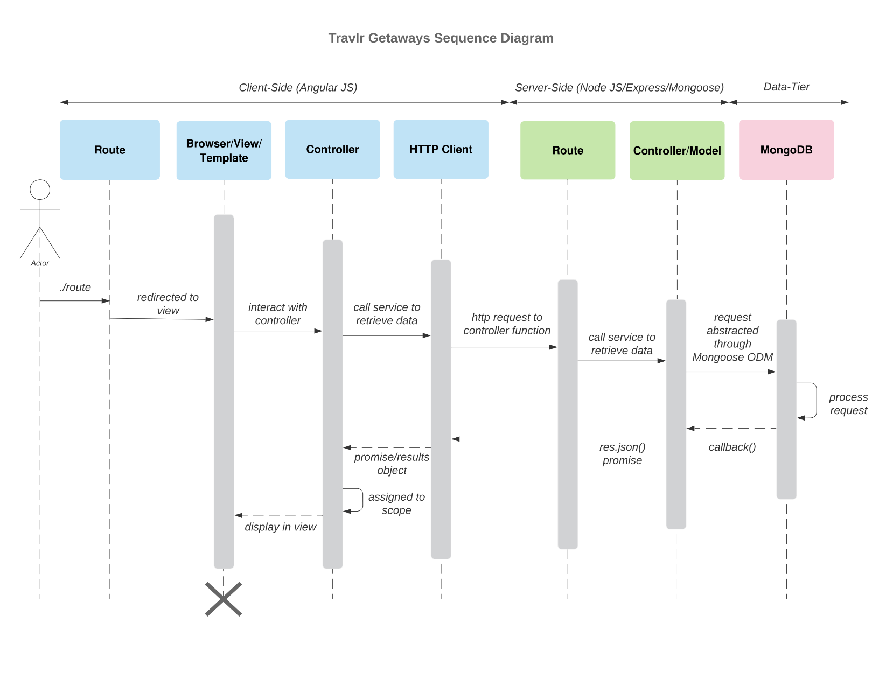The supplied sequence diagram shows the request and response flow between the client, server, and database. Angular uses HttpClient to request trip JSON. The Express Travel controller requests the same API and passes the result to Handlebars. Mongoose handles the database call, and the result appears in the page or trip cards. Staff sign-in uses Passport and a signed token. Customer signup and sign-in use a separate account model and token. Before a reservation is saved, the server checks the customer, reads the trip’s price, and calculates the total. Invalid tokens are rejected before protected data changes.

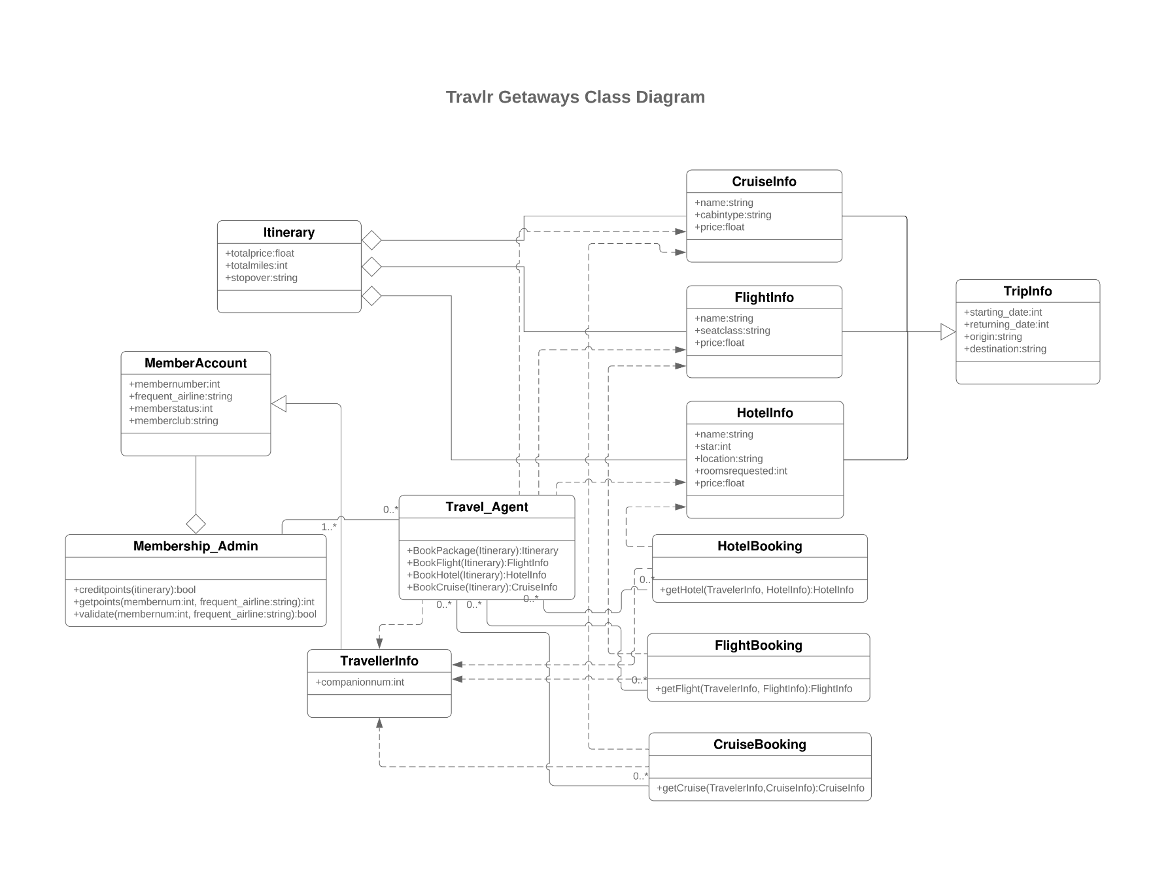
Class Diagram

The class diagram above shows the larger booking design. TripInfo shares trip details with FlightInfo, CruiseInfo, and HotelInfo. Itinerary groups these services and keeps track of the totals.
TravellerInfo and MemberAccount store traveler and account information. Membership_Admin handles rewards, and Travel_Agent works with the booking classes.
The current application uses four Mongoose models: Trip, User, Customer, and Reservation. Each reservation belongs to one customer and stores the trip details, number of travelers, price, total, and status. These saved details stay the same if the trip changes later. The flight, cruise, membership, and reward classes are part of the larger design, but those connections have not been built yet.

API Endpoints

The API runs in app_api on local port 3000. Trip routes use the code field, such as SUNSET2027. Public GET requests support browsing and search. Staff and customer endpoints require their own valid Bearer tokens, as noted below.

Method | Purpose | URL | Notes
GET | Get all trips | /api/trips | Public. Returns a JSON array with 200.
GET | Get one trip | /api/trips/:tripCode | Public. Returns an array with 200, or 404 when the trip is missing.
POST | Add a trip | /api/trips | Staff token required. Returns 201; invalid data returns 400 and a duplicate code returns 409.
PUT | Update a trip | /api/trips/:tripCode | Staff token required. Returns the saved trip with 200; invalid data returns 400 and a missing trip returns 404.
DELETE | Remove a trip | /api/trips/:tripCode | Staff token required. Returns 204, or 404 when the trip is missing.
POST | Sign in | /api/login | Returns a one-hour JWT with 200. Incorrect credentials return 401. Repeated attempts are rate limited.
POST | Create a staff account | /api/register | Existing staff token required. Returns 201; duplicate email returns 409. The first administrator is created locally with create-admin.
Customer and reservation endpoints
Method | Purpose | URL | Access
POST | Create an account or sign in | /api/customer/register  /api/customer/login | Public; returns a customer token. Signup checks matching passwords.
GET | Read my account | /api/customer/me | Customer token; active account required.
GET / POST | List or create my reservations | /api/customer/reservations | Customer token. The server calculates pricing; creation returns 201.
GET | Open my itinerary | /api/customer/reservations/:reservationId | Customer token; another customer’s record returns 404.
PATCH | Cancel my reservation | /api/customer/reservations/:reservationId/cancel | Customer token; only a future reservation belonging to that customer.
GET / PATCH | List customers or change access | /api/customers  /api/customers/:customerId | Staff token. PATCH changes active status without deleting history.
GET / PATCH | List bookings or change status | /api/reservations  /api/reservations/:reservationId | Staff token. PATCH accepts confirmed or cancelled.
GET / PUT | Read or update staff profile | /api/staff/me | Staff token. PUT updates the name and returns a refreshed token.

The User Interface

Angular stores its components, templates, styles, models, and services in app_admin/src/app. Trip Listing uses a Trip Card component for each trip. Add Trip, Edit Trip, and Login each have their own component. The sidebar also has Reservations, Users, and Settings. Services send API requests, an interceptor adds the staff token, and route guards send users who are signed out to the login screen.

The Express customer site keeps its routes, controllers, and Handlebars views in app_server. Customers can search trips, create an account, sign in, review checkout, and view saved itineraries. The Reservations link only appears in the header when a customer is signed in. Express builds each page on the server. Angular updates its screens in the browser without reloading the whole application.
We tested GET by loading the trip listing and opening Sunset Cove Getaway in the Edit form. All eight fields loaded from the API, including the saved start date. We tested PUT by changing the name to Sunset Cove Getaway Plus and the price from $1,299 to $1,399. After saving, the updated card appeared with a success message. We also checked MongoDB and the customer Travel page to confirm the changes were saved.
The final checks passed: 17 API tests, seven Angular tests, and the earlier 25 checks across 11 Postman requests run through Newman. The new tests checked account creation, staff and customer permissions, reservation ownership, server pricing, duplicate checkout protection, and saved itinerary details. Browser testing covered signup, checkout, cancellation, customer access controls, and settings. We removed temporary test records after saving the screenshots.
Administrator sign in
Staff sign in before managing trips. Passwords are not stored as plain text, and a route guard keeps signed-out visitors out of the admin forms.
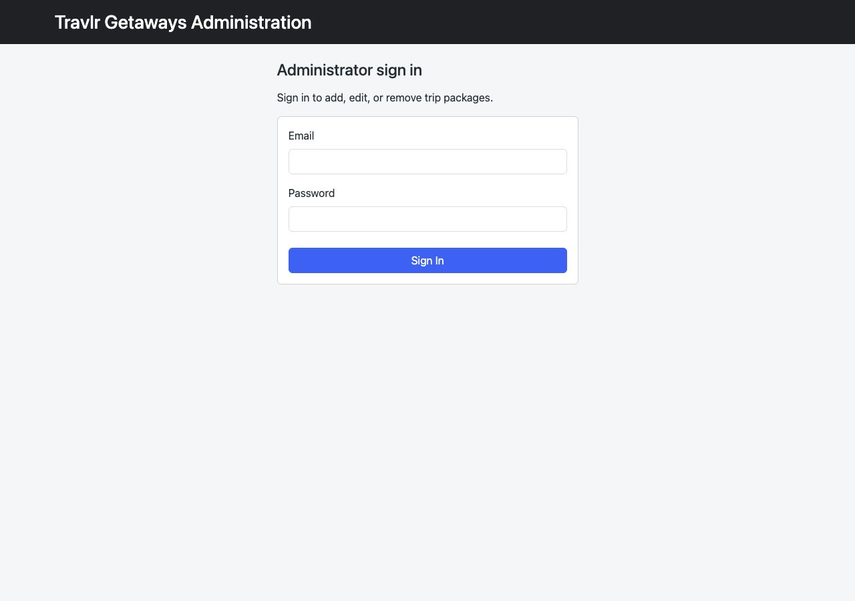
Additional trip in the listing
The current listing shows the five real trips, including our added Coral Cove and Sunset Cove examples. The temporary API test trip is removed.
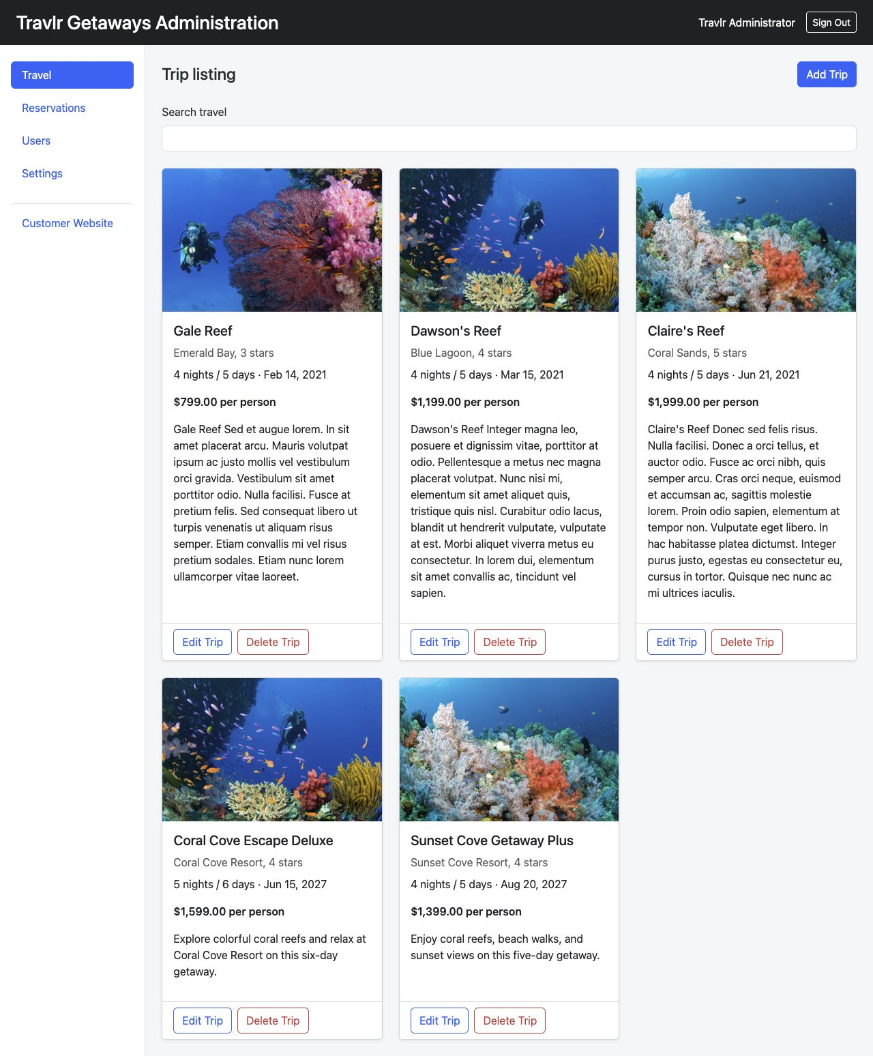
Edit screen
The Edit form shows Sunset Cove Getaway Plus with its saved $1,399 price.
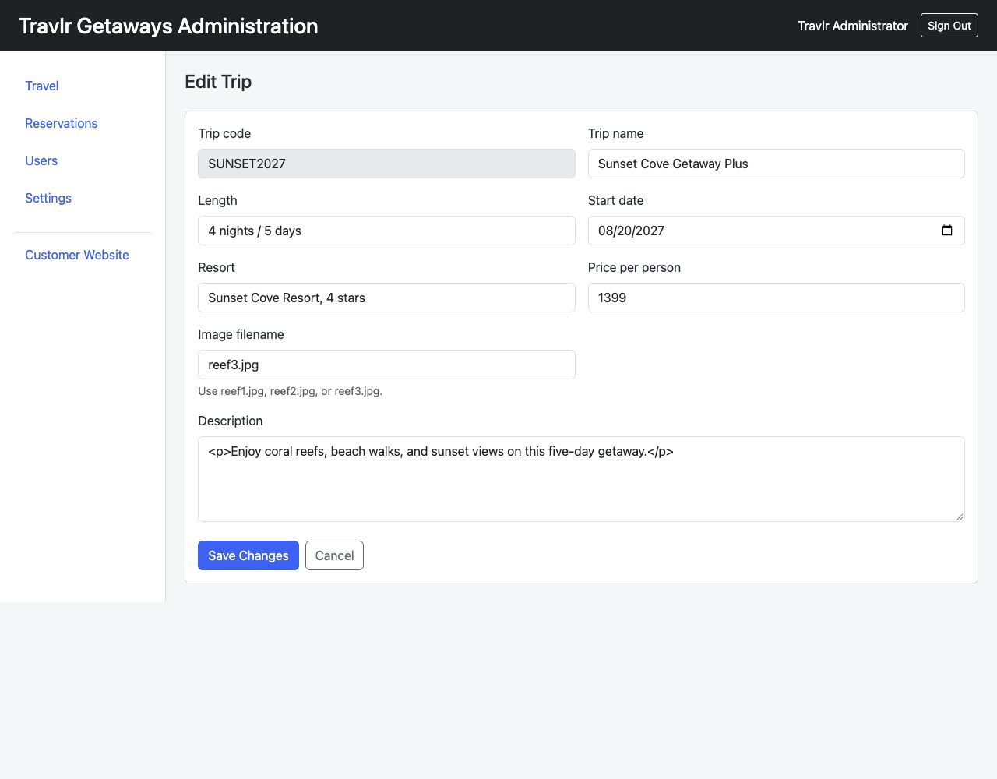
Update screen
Saving returned a success message. Searching for Sunset shows its saved $1,399 price.
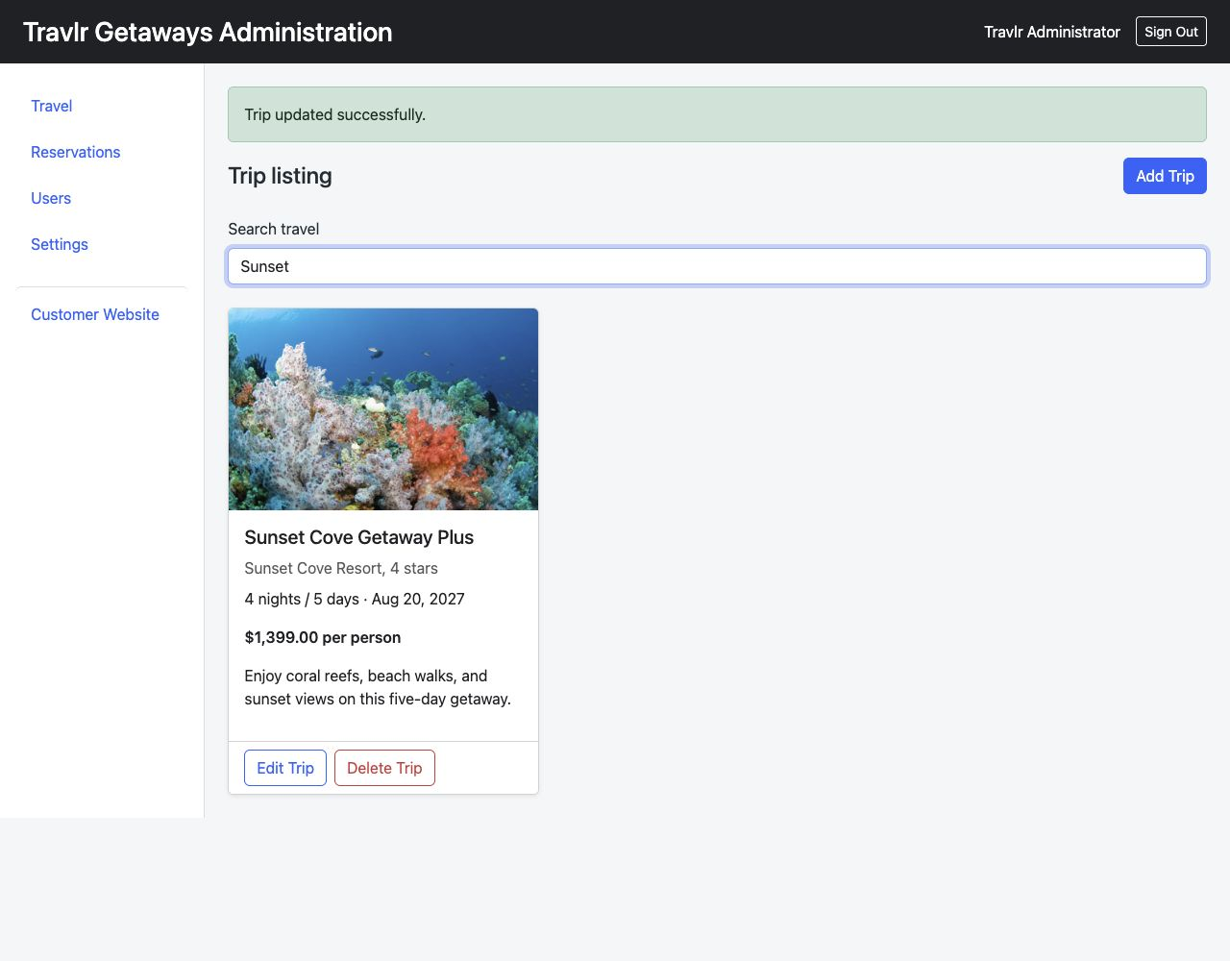

Customer signup
I created a customer account with a name, email, and matching passwords. After signup, the site returns to checkout.
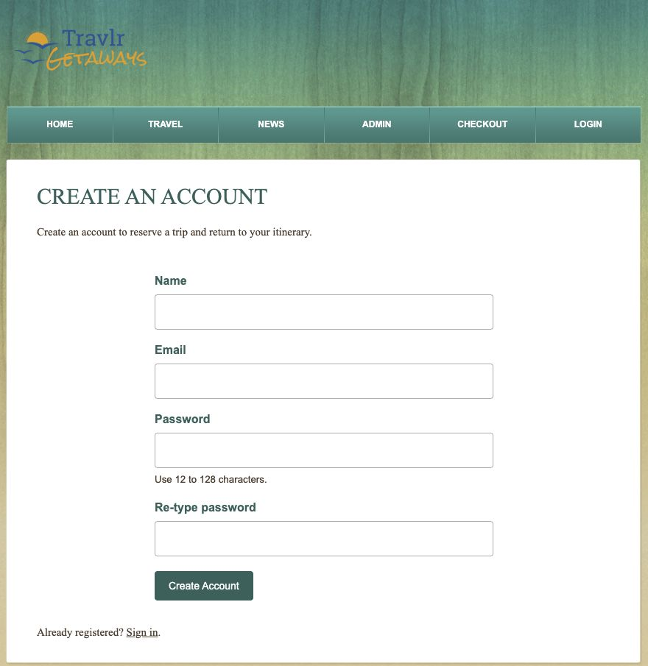
Customer account and staff access
My Account confirmed the new customer was saved. The same account appeared under Users in the admin SPA, where staff can disable or reactivate access.
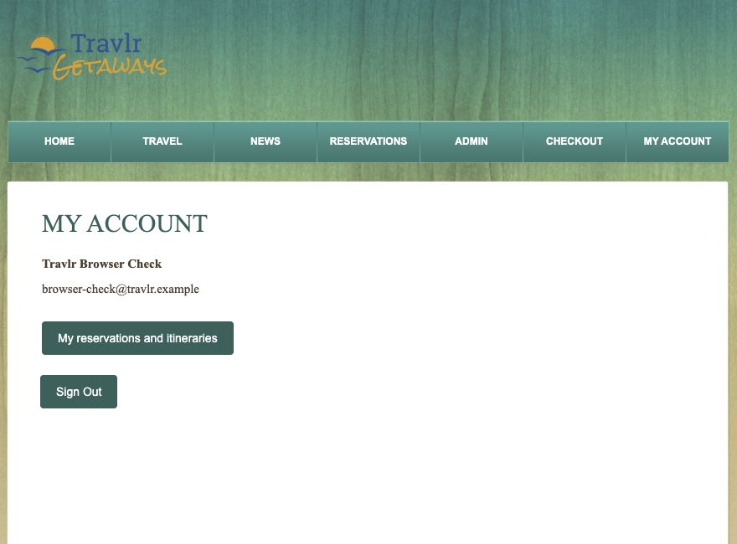
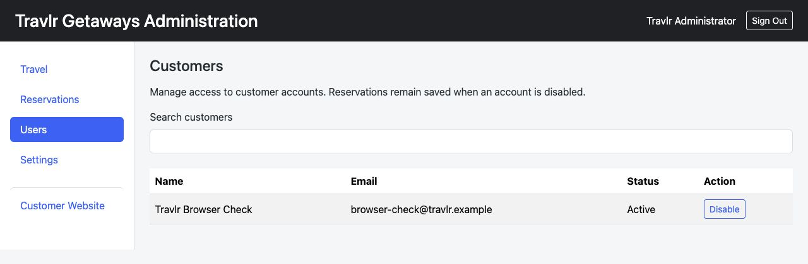
Trip search
Searching for Sunset with a $1,500 maximum returned the matching $1,399 trip. The existing trip description stays the same.
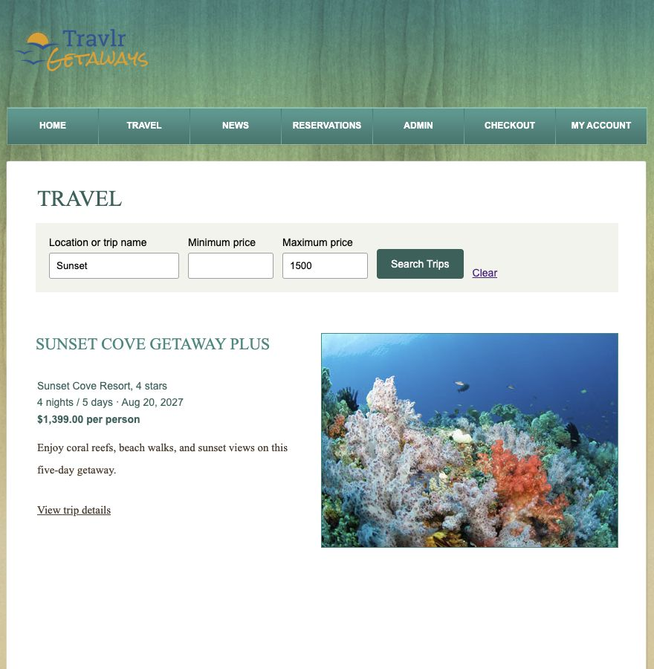
Reservation checkout
Two travelers at $1,399 each gave a $2,798 total. The server uses the saved trip price when it creates the reservation. No online payment is collected.
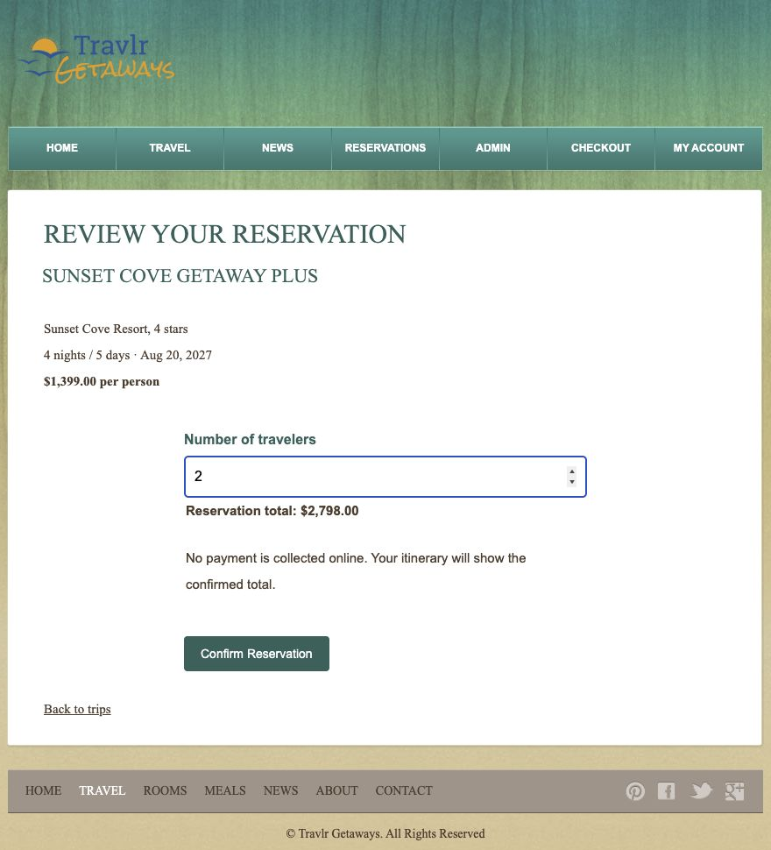
Saved itinerary
The itinerary kept the trip details, two travelers, and the $2,798 total. Cancelling it from the staff screen changed the customer’s saved status to cancelled.
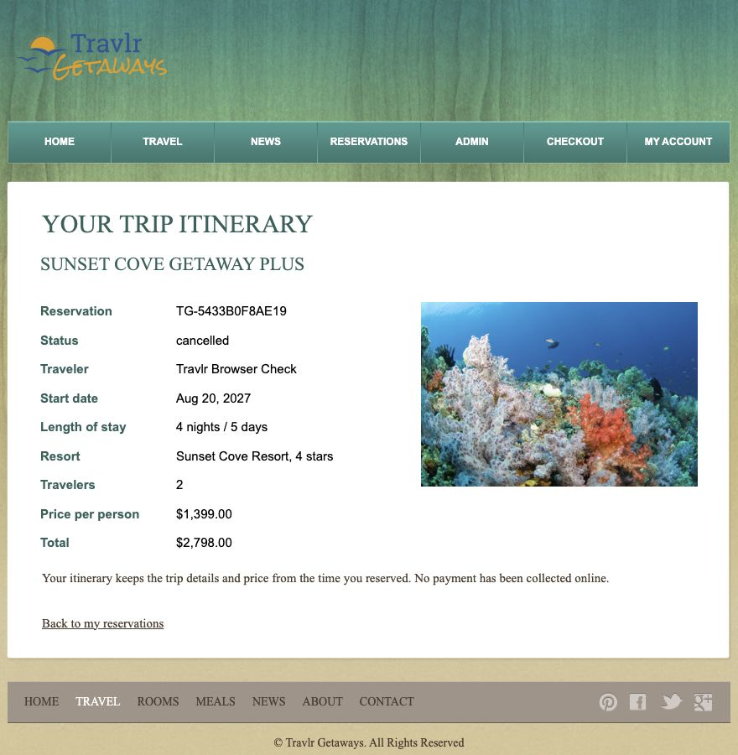
Staff reservation management
Reservations lets staff review bookings and change their status. Settings saves the staff display name. Both screens were checked in the browser.


